Adders:
Half Adder Equations:
$S=A⊕B$
${ C}_{out}=AB$

Half Adder:
A | B | C_{out} | S
0 | 0 | 0 | 0
0 | 1 | 0 | 1
1 | 0 | 0 | 1
1 | 1 | 1 | 0
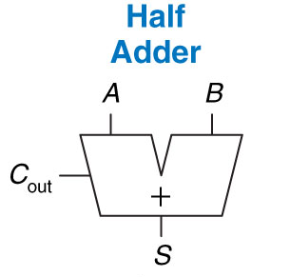
Half Adder Limitations?
- Limited in function. Doesn’t contain circuitry to take/make use of C_{in}/C_{out}.
Half Adder Schematic:
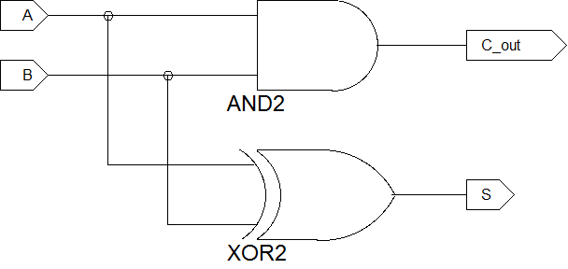

Half Adder Limitations?

Full Adder:
C_{in} | A | B | C_{out} | S
0 | 0 | 0 | 0 | 0
0 | 0 | 1 | 0 | 1
0 | 1 | 0 | 0 | 1
0 | 1 | 1 | 1 | 0
1 | 0 | 0 | 0 | 1
1 | 0 | 1 | 1 | 0
1 | 1 | 0 | 1 | 0
1 | 1 | 1 | 1 | 1
XOR
A | B | Y
0 | 0 | 0
0 | 1 | 1
1 | 0 | 1
1 | 1 | 0

Full Adder Equations:
$S=A⊕B⊕C_{in}$
${ C}_{out}=AB+AC_{in}+BC_{in}$

Go over 3-input XOR and the K-maps
XOR is essentially an odd parity detector

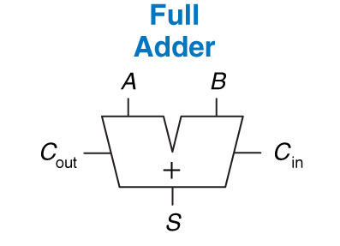

Carry Propagate Adder:
Carry Propagate Types:
- Ripple Carry
- Carry Lookahead
- Prefix
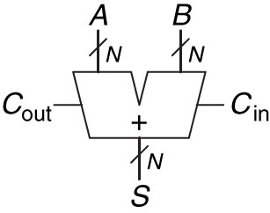
Ripple Carry:
Delay Equation: (may need on GR)
$t_{ripple}=Nt_{FA}$
- N-Full Adders Chained (show how to chain)
- Delay grows Linearly…
Easy, but super slow for large N
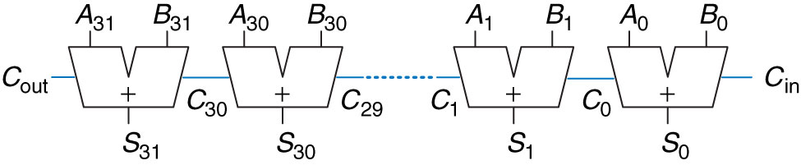
Carry Lookahead:
Delay for N-bit Adder with k-bit blocks:
$t_{CLA}=t_{pg}+t_{pg_block}+\left(\frac{N}{k}-1\right)t_{and_or}$ + k$t_{FA}$
Where $t_{pg}+t_{pg_block}$ are individual P/G gates (AND,OR) time to find $P_{i:j}$ and $G_{i:j}$ for a block
- Divides adder up into blocks to determine carry out ASAP
- N > 16: – we start to see timing gains
– Faster than Ripple carry
- Delay still grows Linearly

Generate – if carry out (C_{out}) produced independently of carry in (C_{in})
$G=AB$
$G=A_{i}B_{i}$
$P=A_{i}+B_{i}$
$C_{i}=A_{i}B_{i}+\left(A_{i}+B_{i}\right)C_{i-1}=G_{i}+P_{i}C_{i-1}$
We can look at G&P for multiple-bit block
$C_{i}=G_{i:j}+P_{i:j}C_{j}$
i.e means we will generate a carry
Propagate –
$P=A+B$
means we will propagate (i.e. pass) a carry
Examples:
$\frac{\begin{aligned} 1010 \\ +0110\end{aligned}}{ }$
$C_{out}=$?

$\frac{\begin{aligned} 1001 \\ +0010\end{aligned}}{ }$
$C_{out}=$?

$\frac{\begin{aligned} 1001 \\ +0010\end{aligned}}{ }$ $C_{in}=1$
$C_{out}=$?

$\frac{\begin{aligned} 1011 \\ +0111\end{aligned}}{ }$
$C_{out}=$?

$\frac{\begin{aligned} 1010 \\ +0101\end{aligned}}{ }$
$G_{1}=1$
$P_{2,3}=1$

Yes there is a carry!
No Carry!
$C_{out}=$?

$\frac{\begin{aligned} 1010 \\ +0101\end{aligned}}{ }$ $C_{in}=1$
No Carry!
Add $C_{in}$ Yes there is a carry! $P=A+B$
$C_{out}=$?
Add $C_{in}$ still No Carry!
$\frac{\begin{aligned} 1000 \\ +1000\end{aligned}}{ }$
Yes there is a carry!
$G=AB$
$C_{out}=$?
Yes there is a carry!
$G_{0,1}=1$
$P_{1,2,3}=1$

Yes there is a carry!
Why? Because of multiplication. We will have a carry in the i^{th} most bit
$\frac{\begin{aligned} 1011 \\ +0101\end{aligned}}{ }$
$C_{out}=$?
Since we generate carry in Bit 0 and then propagate through 13 we have a C_{out}
$G_{0}=1$
$P_{1,2,3}=1$

Why?

$$C_{i}=A_{i}B_{i}+\left(A_{i}+B_{i}\right)C_{i-1}=G_{i}+P_{i}C_{i-1}$$

Generate Propagate Schematic:
In general, start with bit 0 and check to see if it generates a carry:
AND – next column propagate
OR – next column generate
AND – next column propagate

Prefix Adder:
$t_{PA}=t_{pg}+{Log}_{2}N\left(t_{pg-prefix}\right)+t_{XOR}$
- Looks ahead by 2^{x} columns
- Makes adder faster
Delay grows Logarithhmically

Subtractors:
How do we subtract?
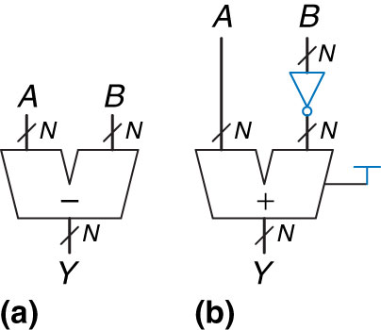
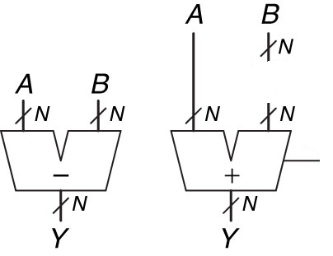
2’s Complement Subtracting:
- add the negative of a number B
- Flip the bits of B and add 1

Comparators:
Equality Comparators:
XNOR
A | B | Y
0 | 0 | 1
0 | 1 | 0
1 | 0 | 0
1 | 1 | 1

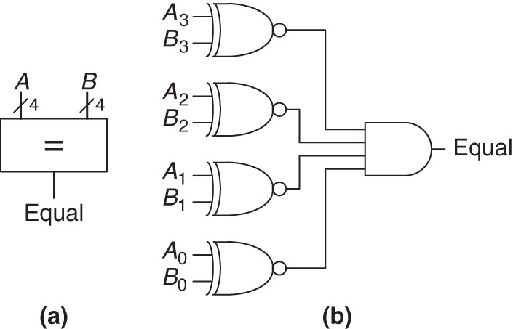

Magnitude Comparators:
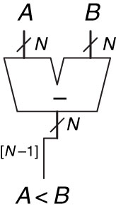
Look @ MSB
If negative number A < B

Draw an N-Bit Comparator:
Block Diagram of N-Bit Comparator:

Why are Comparators useful?
Comparators are Boolean If Statements in code

Implement this function using things we learned today?
No Gates..Just Logic Functions
If a < 4
z = y + 3
else
z = y + 7

